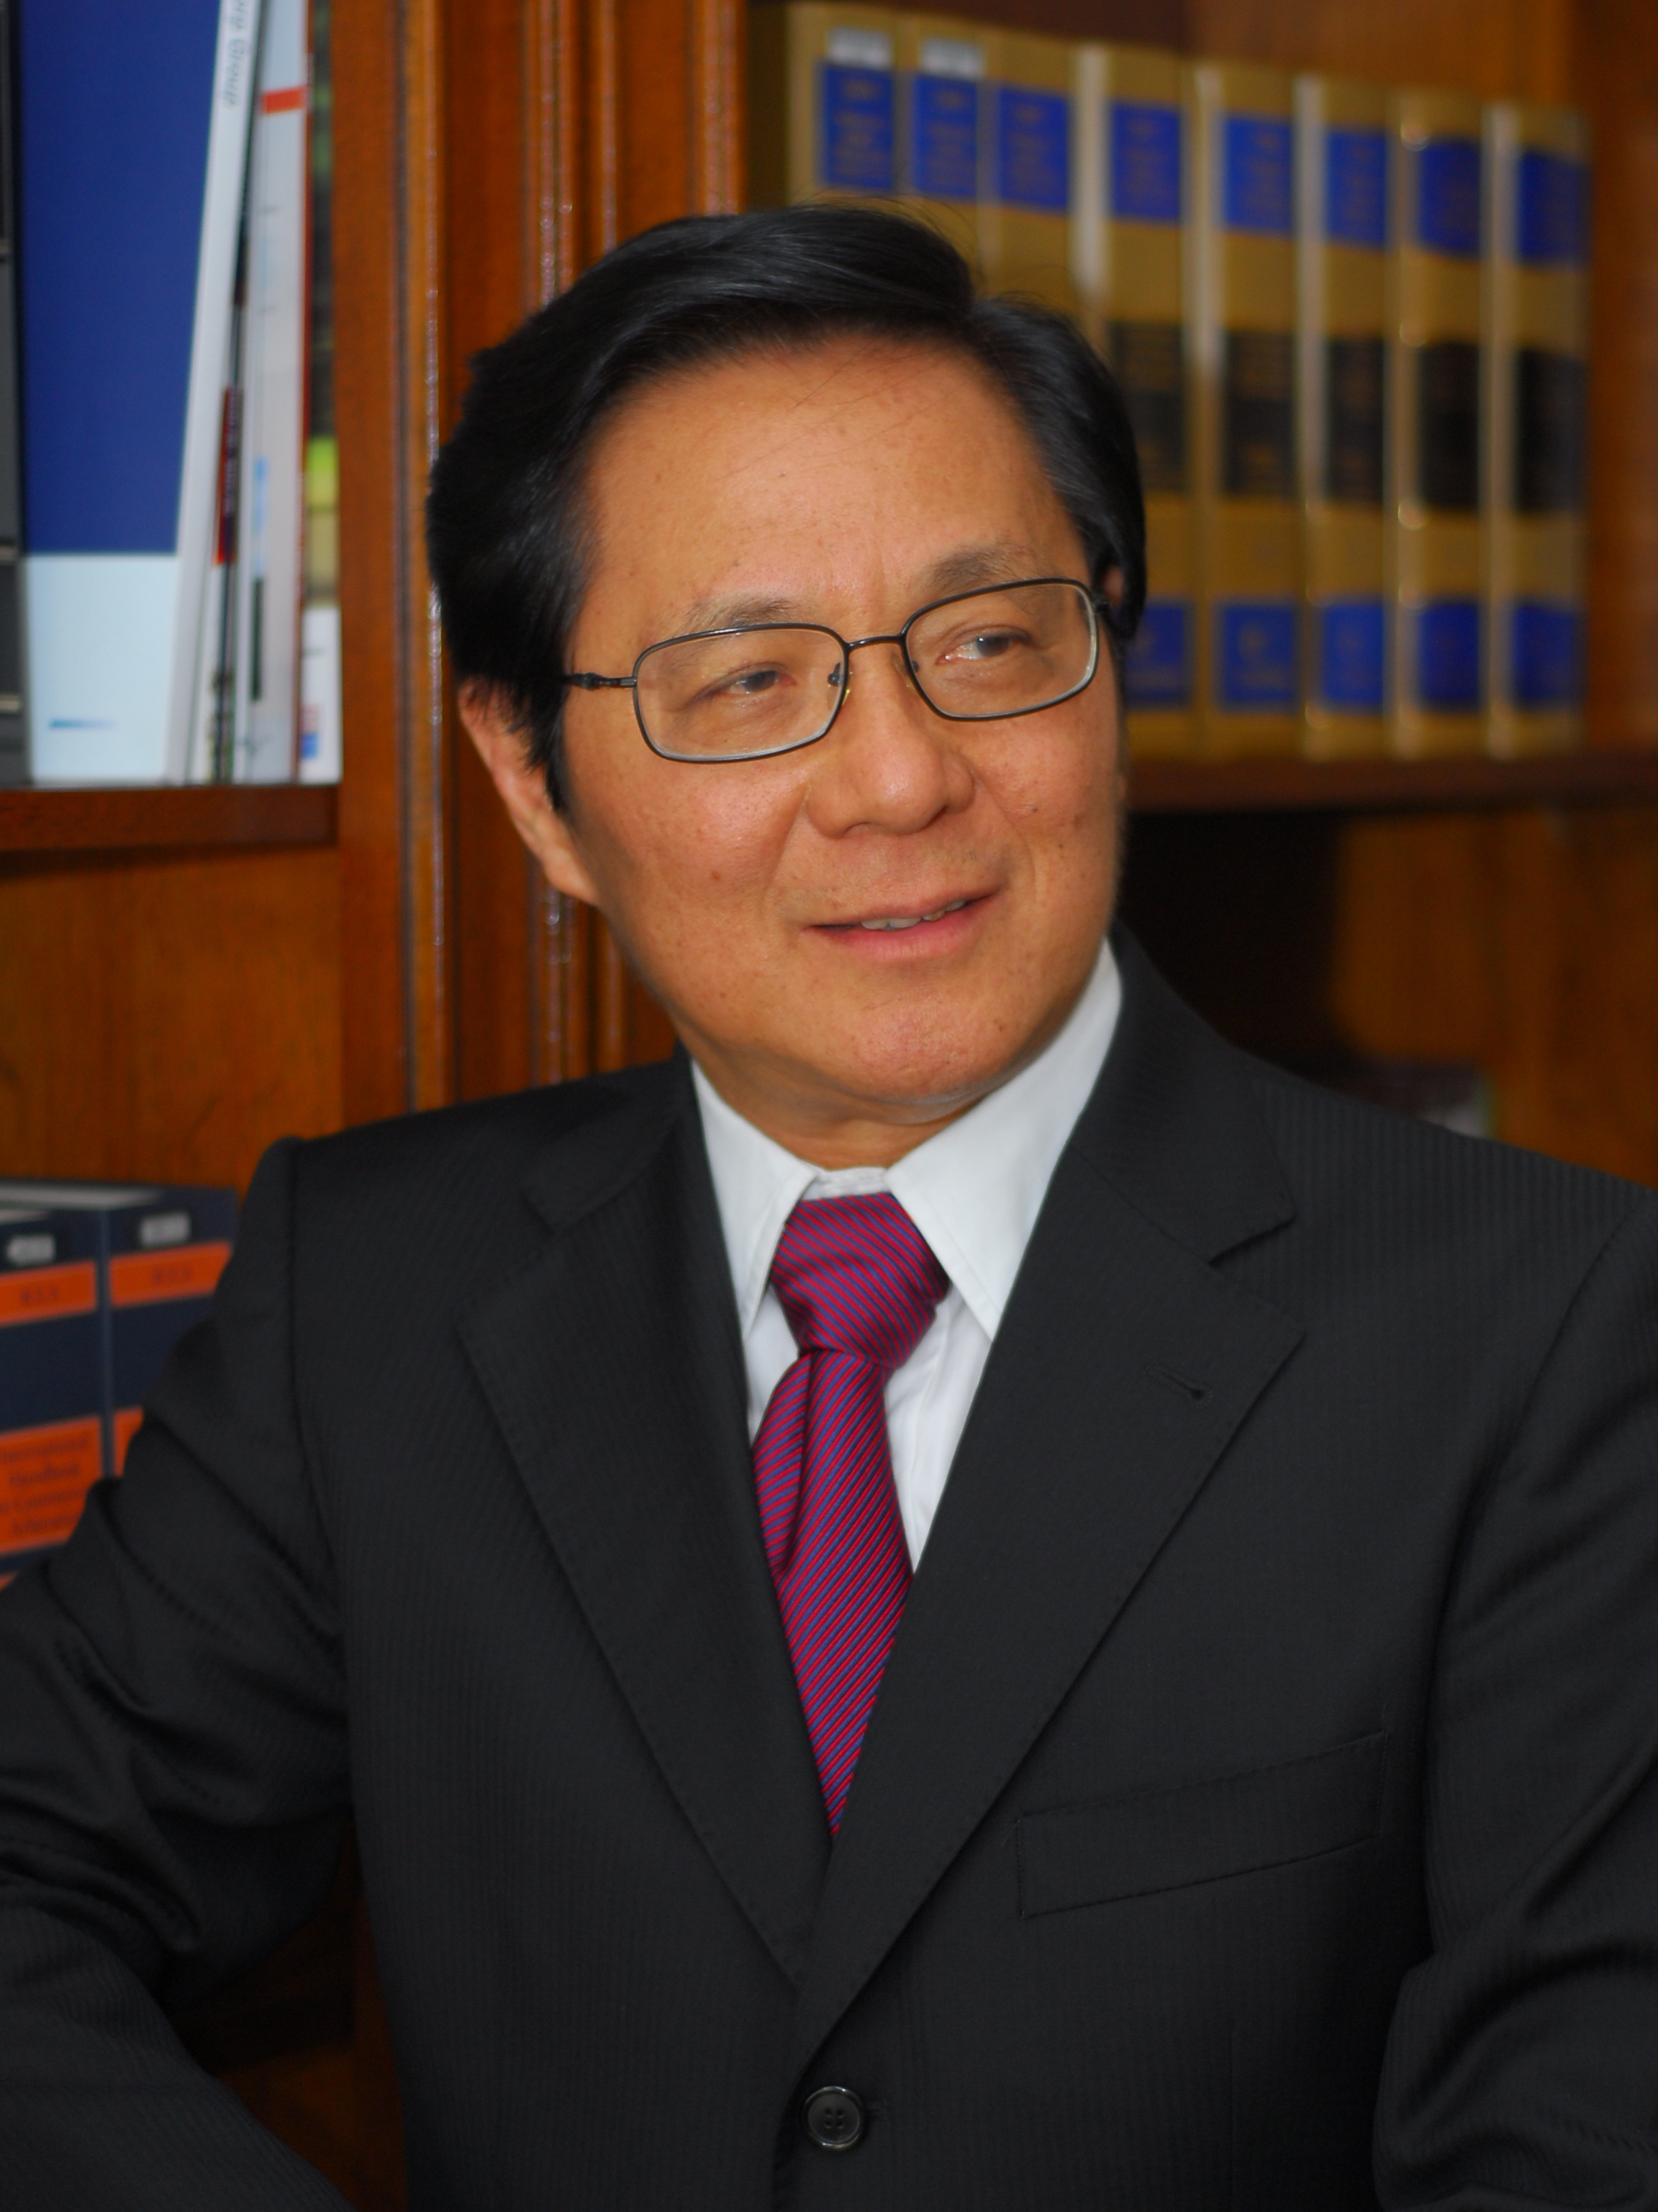
Prof. Dr. Frans H. Winarta, S.H., M.H.
Senior Partner & Managing Partner
Frans Winarta & Partners Law Firm
franswinarta@fwp.co.id – www.franswinarta.com
Kompleks Bukit Gading Mediterania (Florencia)
Boulevard Bukit Gading Raya Blok A 15-17
Kelapa Gading Permai
Jakarta 14240,
Indonesia

At present, Prof. Winarta is the Senior Partner & Managing Partner of Frans Winarta & Partners Law Firm. He handles all aspects of civil, commercial and criminal litigation. He is also experienced in international and national arbitration and alternative dispute resolution.

Prior to his qualification as an advocate, Prof. Winarta was a Bachelor of Law at Parahyangan Catholic University in Bandung. He obtained a Master’s Degree in Criminal Law at the University of Indonesia in Jakarta and a Doctorate Degree in Law at Padjajaran University in Bandung. Recently, in April 2015, he was inaugurated as a Professor of Law at Pelita Harapan University.

Prof. Winarta is well known as a reputable national and international arbitrator. He has experience in various kinds of disputes ranging from construction issue, oil and gas issue, mining issue, energy issue, cross-border investment issue, taxation, and many more. He has been awarded as a Fellow Certified BANI Arbitrator (FCBArb.), given under the seal of the Indonesian National Board of Arbitration (BANI). He functions as the Co-Chairman and Founder of the Indonesian Chapter of the Chartered Institute of Arbitrators (CIArb). He is also an Associate of the Chartered Institute of Arbitrators (ACIArb.) and Chairman of the Arbitration Commission of the Indonesia Chapter of the International Chamber of Commerce.

For over nine years (2006-2015), Prof. Winarta has been a member of the International Court of Arbitration of the International Chamber of Commerce (ICC) in Paris. In 2011, he was appointed by the Executive Committee of SIAC to be a member of the Panel of Arbitrators of the Singapore International Arbitration Centre (SIAC). In 2012, he was appointed to the Panel of Arbitrators of the Kuala Lumpur Regional Centre for Arbitration (KLRCA), and also Panel of Arbitrators of the South China International Economic and Trade Arbitration Commission, Council of Shenzhen Court of International Arbitration (SCIA). In 2014, he was appointed to the Panel of Intellectual Property Arbitrators of the Singapore International Arbitration Centre (SIAC). Recently, he was appointed to the Panel of Arbitrators of the Hong Kong International Arbitration Centre (HKIAC).

Prof. Winarta has written numerous articles, chapters and literature on various issues on Indonesian law which have been published in law journals and books, and is an active lecturer at Pelita Harapan University. During his practice as an advocate, he has been admitted to the American Bar Association (ABA) and also became a Country Representative for Indonesia of the International Bar Association (IBA) in London. During 1991-1993, Prof. Winarta was registered as a Council Member of the Inter-Pacific Bar Association (IPBA) in Tokyo, and he was also registered as a Council Member of LawAsia in Perth from 1992 - 1995.

